

**CONFIDENTIAL**

(24/10/2019)

Project Estimate

**Job Portal**

**Version 1.0**

|  |  |  |  |  |
| --- | --- | --- | --- | --- |
| This document outlines the general scope of your project based on our understanding of the requirements provided and discussions to date. |  | |  | | --- | | **Prepared for:**  **Joseph Mulindwa** | | **Lead ID:**  **70425** | |

**DISCLAIMER**

This document is submitted with the explicit understanding that the contents are confidential and would not be divulged to any third party without prior written consent from Dotsquares Ltd. Services are supplied according to our terms and conditions <http://www.dotsquares.com/terms>

# Revision History

|  |  |  |  |  |
| --- | --- | --- | --- | --- |
| **Version** | **Date** | **Description** | **Prepared by** | **Reviewed by** |
| 1.0 | 24/10/2019 | Project Scope | Nikhil | Sachin |

Contents

Revision History 2

Purpose of the Document 5

Project Objective 5

Scope of Work 5

Deliverables 6

Receivables 6

User Journey 7

System Features 8

Website designing 8

Staff Panel 8

Homepage 8

Register 8

Login and forgot password 9

Search Panel 9

Search Result Page 9

Filter Options 9

Job details 9

Staff Dashboard 10

Manage Profile 10

Applied Jobs Listing 10

Employer Listing 10

Change Password 10

FAQ / Help 10

Informative pages / screens 11

Client Panel 11

Register 11

Login and forgot password 11

Admin Panel: 12

Login and forget password 12

Dashboard 12

Admin settings 12

View Staff 12

View Clients 12

Manage Job Categories 13

Manage Job Types 13

View Jobs 13

Technology 14

Estimate Details 14

Estimate Breakdown 14

Previous Work: 16

Important Notes 16

Content Submission 16

Software & Platform Updates 16

Project Management Tool (DS Projects) 16

Project management and monitoring CMMi Level 3 compliance 17

Warranty 18

Intellectual Property Rights 18

Testing 18

Environment 19

Additional Services 19

Support 20

Network Support 20

Digital Marketing 20

Why Dotsquares 21

What we do… 22

Affiliations 22

Portfolio 23

What our clients say 23

# Purpose of the Document

This document outlines the general scope of your project based on the requirements provided and discussions to date. The main objective at this stage is to ensure that all parties agree upon the general scope, budget and schedule of the project prior to commencing work on subsequent stages (which can include in-depth planning if needed).

Clients are urged to ensure that all the details contained within this document are clear and fully meet their requirements before any work commences. Timescales mentioned only cover the scope listed, if this changes, costs and timings will change accordingly.

Once you are happy contact us and we will progress into the next stages. This may include further detailing requirements and functionality or it may go straight into design. This will depend on the nature of the project.

# Project Objective

The objective of the project is to create a platform for staff and client. Staff and client can create and edit their profiles and list/search for the jobs.

Clients can post their job on the website. These listings will be manually approved and posted by the admin. Once a listing has been posted by the client, then it could be easily searched and accessible to staff member who can further apply on it. A staff member can also browse various job categories and can view available jobs within that category. Website will have some information content pages.

Staff member will search the jobs and raise the job request which will be approved by the admin.

Staff member can propose themselves (put their names down) for any available work they are interested in after logging in. Admin too can propose any staff who have uploaded their **availability** for work.

Further scope of the system includes an admin panel, through which the Website insight can be managed.

# Scope of Work

The scope of work include the development of job portal for staff member and clients in website.

## Deliverables

|  |  |  |  |
| --- | --- | --- | --- |
|  | **Item** | **User** | **Device/Platform** |
| 1 | Website Designing | Client/Staff Member | Adobe Photoshop |
| 2 | Complete backend  (source code) | Web Application Admin | Admin Panel |
| 3 | Database | - | MySQL |

## Receivables

|  |  |  |
| --- | --- | --- |
|  | **Item** | **User** |
| 1 | Hosting/Domain details | Client |
| 2 | Google Map Account | Client |

## User Journey

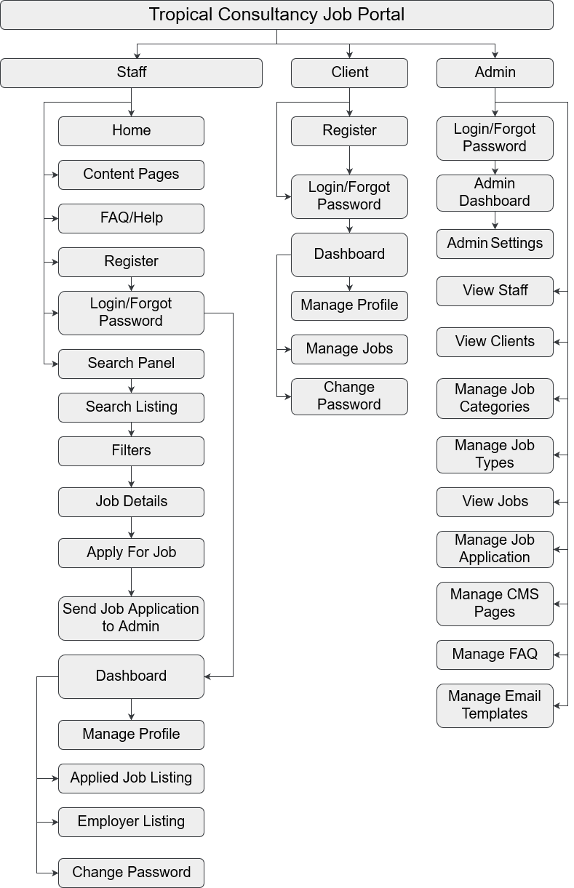

## System Features

### Website designing

Design of website will be done as per market standards and consists of steps:

* PSD Designing of web pages
* Creating mobile responsive HTML

Designing points:

* The website should be very clean and clear for customers to be able to read and browser through it easily.
* The homepage should not be too busy with loads of information and buttons to click makes the website very difficult to browse.
* Website designs, fonts will be high resolution with better look and feel.

## Staff Panel

### Homepage

* Home page will be the main page of the website
* A staff will be able to see all the inner webpage links.
* A staff will be able to search for jobs by using the search panel where staff can enter the location where they want to search jobs.

Home page will be showcasing the following items:

* Top menu
  + Home
  + Jobs
  + Contact us
  + How it works
* Banner with search bar
* Jobs Category Section
* Information content
* Testimonials section
* Footer
  + FAQ
  + Terms and conditions
  + Testimonials
  + Contact us
  + Privacy policy

Social media links (Facebook, Twitter, and Google)

### Register

* Enter email address
* Enter password
* Send automated email for verification

Upon verifying the email, a staff can login to the website.

Signing in and signing up should be made easy like on this website

*Note: We will provide standard registration process but if you require registration through Gmail, Yahoo mail, AOL mail and Hotmail then it will take additional amount of time for this module.

### Login and forgot password

Login

* Login using email address and password

Forgot Password:

* Remember Password using registered email address
* Reset Password Email
* Reset Password Screen

Redirect/ navigate to Login Screen

### Search Panel

Staff can search the available jobs by entering the post code. We will integrate the 3rd Party API to manage the post code and locations.

### Search Result Page

Website will list entire Jobs under this section that matches with Staff search preferences. Below would be the required information we will be showing:

* Views
  + List (listing of Available Jobs)
* Jobs
  + Postcode
  + Miles Away from your location
  + Job code
  + Job title and small description
  + Job Location
  + Option to view Job details

### Filter Options

A staff can filter the results through these below criteria:

* Miles
* Location
* Job Category
* Total Experience
* Job Type i.e. Full Time, Part Time

### Job details

This section will represent job details with various options as listed below:

* Job code
* Job title and long description
* Job Starts and End Time
* Location
* Job Category
* Job Type
* Location on map
* Option to Apply For Job

### Staff Dashboard

We will show the staff content in this section.

* View Profile
* Edit Profile
* View Listing of Applied Jobs
* View My Employer List i.e. Past and Current
* Change Password
* Logout

### Manage Profile

Staff will manage these below items from this profile page.

* Name
* Email Address
* Postal Address
* Contact Details
* Job Category
* Job Type
* Total Experience
* Past Employer
* Current Employer
* Manage Availability
  + Available
  + Not Available

### Applied Jobs Listing

Staff will view the listing of jobs from who are applied.

### Employer Listing

Staff will view the past and current employer listing.

### Change Password

Staff will manage their account password from this section.

### FAQ / Help

Staff can see the FAQ section where we can list all the questions and answers that are added by the site administrator.

### Informative pages / screens

* About us
* Disclaimer
* Privacy policy
* Contact us Page- We will be going to display the contact number for enquiries, contact form, email address, postal address and location on map.
* Terms and conditions
* Any other custom page developed by admin in backend under CMS module

## Client Panel

### Register

The client can register on the website by:

* Enter email address
* Enter password
* Send automated email for verification

Upon verifying the email, a client can login to the website.

Signing in and signing up should be made easy like on this website

*Note: We will provide standard registration process but if you require registration through Gmail, Yahoo mail, AOL mail and Hotmail then it will take additional amount of time for this module.

### Login and forgot password

Login

* Login using email address and password

Forgot Password:

* Remember Password using registered email address
* Reset Password Email
* Reset Password Screen

Redirect/ navigate to Login Screen

Employer Dashboard  
we will show the client content in this section.

* View Profile
* Edit Profile
* Manage Jobs
* Change Password
* Logout

Manage Profile  
Client will manage their profile.

* Name
* Email Address
* Postal Address
* Contact Details

Manage Jobs  
Client will manage the jobs from this section.

* Job Title
* Job Description
* Job Starts and End Time
* Job Category
* Job Type
* Minimum and Maximum Experience Required
* Postcode
* Location

Change Password  
Client will manage their account password from this section.

## Admin Panel:

The Admin Panel (Backend) will be a restricted access area. Following section/modules will be there in it:

### Login and forget password

* Admin will login using Email ID/username and password.
* Allow admin to retrieve password if forgotten
* Change Password

### Dashboard

* Total number of Staff
* Total number of Clients
* Total active Jobs
* Total Job Applicant

### Admin settings

* Change password
* Manage general site settings

### View Staff

* Admin will be able to view the listing of the already registered staff.
* Admin will assign the jobs to the Available Staff

### View Clients

Admin will be able to view the listing of the already registered clients.

### Manage Job Categories

Admin will be able to manage the job categories from this section.

* Add Job Category
* Edit Job Category
* Delete Job Category
* View Job Category Details

### Manage Job Types

Admin will be able to manage the job types from this section.

* Add Job Type
* Edit Job Type
* Delete Job Type
* View Job Type Details

### View Jobs

Admin will be able to view the listing of already added jobs.

Manage Job Application

Admin will be able to manage the job application from this section.

* View Job Applications
* Accept or Reject Job Application
* Admin will assign the jobs to the Available Staff

Manage Information Pages CMS

This part is used to manage the information pages of the system, following details are managed for information pages:

* Meta Title
* Meta Keywords
* Meta Description
* Page Content

FAQ Management

Admin can manage the questions and answers of the FAQ section at frontend.

E-mail template manager

Admin can view existing email templates which are sent to users on various activities. These templates can be edited.

## Technology

|  |  |  |
| --- | --- | --- |
|  | **Component** | **Website** |
| 1 | Operating system | Linux |
| 2 | Server | Linux |
| 3 | Database | MySQL |
| 4 | Web Framework | PHP (Laravel) |
| 5 | Programming Language | PHP |
| 6 | Editor/IDE | NetBeans |

# Estimate Details

## Estimate Breakdown

|  |  |  |  |
| --- | --- | --- | --- |
|  | **Deliverable** | **Modules** | **Estimate**  **(Hours)** |
|  | **Designs** | PSD’s/Mock up | 24 |
|  |  | HTML | 16 |
|  | **Staff Panel** | Home Screen | 6 |
|  |  | Register | 2 |
|  |  | Login & Forget Password | 2 |
|  |  | Search Panel | 2 |
|  |  | Search Result Page | 4 |
|  |  | Filter Options | 4 |
|  |  | Job Details | 4 |
|  |  | Dashboard | 2 |
|  |  | Manage Profile | 2 |
|  |  | Applied Jobs Listing | 2 |
|  |  | Employer Listing | 2 |
|  |  | Change Password | 2 |
|  |  | FAQ / Help | 2 |
|  |  | Informative pages / screens | 2 |
|  | **Client Panel** | Register | Included |
|  |  | Login and forgot password | Included |
|  |  | Dashboard | 2 |
|  |  | Manage Profile | 2 |
|  |  | Manage Jobs | 6 |
|  |  | Change Password | Included |
|  | **Admin Panel** | Login and forget password | Included |
|  |  | Dashboard | 2 |
|  |  | Admin settings | 2 |
|  |  | View Staff | 4 |
|  |  | View Clients | 4 |
|  |  | Manage Job Categories | 2 |
|  |  | Manage Job Types | 2 |
|  |  | View Jobs | 4 |
|  |  | Manage Job Applications | 6 |
|  |  | Manage Information Pages CMS | 2 |
|  |  | FAQ Management | 2 |
|  |  | E-mail template manager | 2 |
|  | Testing & Deployment |  | Included |
|  | **Total Estimated Hours** |  | **120** |
|  | **Total Estimated Days** |  | **15** |
|  | **Total Estimated Weeks** |  | **3** |

|  |
| --- |
| **Estimate is valid for 30 days from date of issue** |

## Previous Work:

* <http://msra.com.au/>
* <https://www.chilterncareers.com/>
* https://www.amherstit.com/
* <http://workking.com/>
* <http://windfarmcrewing.com/>

## Important Notes

We tried to cover major features of the shared requirement. Please share your thoughts if we missed anything to specify or need to be removed so we can do needful and send you the revised estimated proposal. The system can be matured as per your existing system over the time in further phases as we go.

The exact speed of design & development will be affected by client turnaround times, for example responding to designs, how much feedback is given etc. Services are supplied according to our terms and conditions: <http://www.dotsquares.com/terms>

The above estimate is based ONLY on the features which we listed in this document. If you need any other feature (NOT listed in this doc) then the Time Estimate may ramp up/down. It may also vary after sharing your response on the queries being asked in this document.

### Content Submission

(Unless otherwise mentioned in the above estimate details the following applies)

* All logos, text content, images and photography to be supplied by the client in electronic format.
* It is the client’s responsibility to enter the text and images into the site.
* Photos and graphics should be submitted in high resolution format (.jpeg /.png)

### Software & Platform Updates

This is to inform you prior that if a new version releases after providing our estimate document then it would be treated as additional activity. If you want to go forward with the Newly Released version, we would need to revise our estimate accordingly.

## Project Management Tool (DS Projects)

Dotsquares will provide free access to DSP (Dotsquares Projects) which is a project management and collaboration platform for planning, communication and tracking. It helps developers, managers and clients to stay on top of what’s happening define and manage project across teams and organizations, keeping up-to-date with the schedule, work visibility and progress.

* Daily updates served through message posts
* Keeps digital track of conversation
* Milestones and tasks for planning
* Maintain task list for deliverables
* E-mail notifications about updates & other activities

## Project management and monitoring CMMi Level 3 compliance



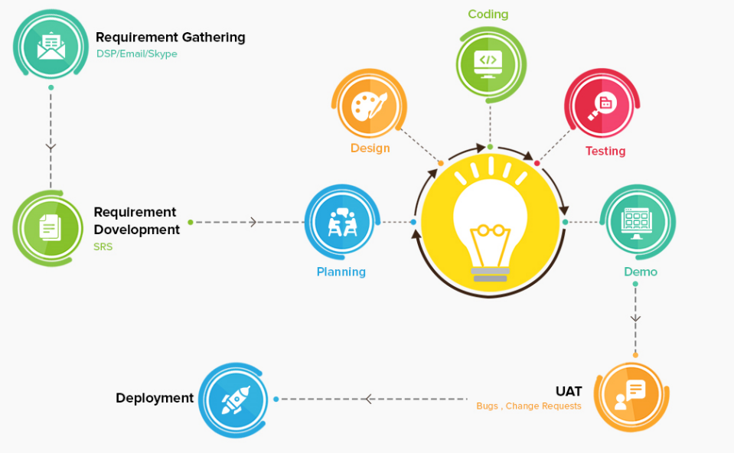Based on the size of your project it classifies to be processed under CMMi level 3 processes for project planning, execution, monitoring and closure.

During the entire project life cycle, we follow a set of processes defined in our organization’s quality management system (QMS)

Apart from delivering the project source code, a range of additional documents are developed and updated throughout the engagement period.

Please consult the below table to get an idea of the activities done throughout the project life cycle and the important documents developed and updated during this process.

|  |  |
| --- | --- |
| Stage | Activity |
| **Initiation** | * Capturing of all email conversations, initial requirement documents and proposal to one place and handing over to Post Sale team for their reference. |
| **Requirement Development** | * A Peer requirement review to ensure requirements were properly captured in the proposal. * Questionnaire and Understandings are exchanged during the requirements gathering. * SRS (Software requirements specifications) containing all functional and possible non-functional requirements is developed and shared with client. * Based on the captured detailed requirement, project is re-estimated for any change or deviation in the flow. |
| **Project Planning** | * Identification of Risks and a mitigation plan to overcome them. * Sets “Sprint Plan”, “Test Plan”, and “Release Plan” * Tasks and activities are developed at granular level for first two sprints |
| **Project Execution** | For each sprint,   * System design is done with mock-ups, business flow and technical architecture * Test cases are developed for the sprint * Code is developed * System is unit tested * System is quality checked * Code review is done * Internal bugs are fixed * Release notes are build and shared with client |
| **Project Monitoring** | * Timesheet for engineering team. * Task status report and burn down chart * Internal project audit by certified auditor |
| **Closure** | * Product audit by the project manager * User Acceptance Testing by client and project manager * Closure report is prepared with the suggestions. |

## Warranty

Your software is delivered with a free warranty of 30 days. You must notify the team during the 30 day warranty period if you identify an error in the code / system / program. Once it has been agreed Dotsquares will correct any errors made in the construction of the code / system / program at no cost. Dotsquares reserves the right to define a bug / error.

## Intellectual Property Rights

All the Intellectual Property created, written, developed, furnished or produced by us during the term of the agreement / project, that are within the scope of the agreement or any applicable Statement of Work shall be the exclusive property of the client. All the code base, assets, documentation (if any) will be handed over to you after development.

## Testing

We provide unit testing services for your project as a standard package. Unit testing is done by the team during development. We ensure all the code blocks (paths) in the software are executed at least once and produce the desired results.

We check the following:

* Graphics and user interface is as per the device resolution.
* App behaviour in absence of communication interface (2G, 3G, HSPA or WiFi).
* Battery drainage and network data consumption during continuous app usage.
* App functionality across various devices built by different manufacturers.
* App installation and first time use.
* Data sync if user changes the device.
* Web applications
  + All links are working.
  + There are no HTTP 404 or 500 errors.
  + Website design is responsive and adapts well to mobile browsing.
  + Web screens show no differences across all leading browsers.
  + Sensitive features are not accessible without valid login.
  + Forms have relevant validation as per the applied use case.
  + There are no spelling and grammar mistakes.
  + Basic security checks.

## Environment

Dotsquares provides free of cost project hosting during the development of your web application.

We upload the solution on our own web and database servers for you to test.

When the project is finished and signed off (production ready), we ask you to choose a hosting provider and deploy the project to live environment.

# Additional Services

Some additional features you might like to include can be found below, unless mentioned in the estimate above they are not currently included. Please let us know if any of these features are required:

* **EU Cookie Compliance:** This gives a viewer the option of not installing cookies, In-line with European privacy laws.
* **PCI Compliance:**This is usually required by your payment gateway supplier as part of your ecommerce merchant account agreement.
* **W3C compliance:** Why bother making your site compatible with specific browsers when you can achieve W3C compliance and make it compatible with all.
* **SEO/Digital Marketing:** Development work is done in-line with best SEO practices, but this does not include SEO optimization (keyword generation, search engine submission, analytics etc). Please see ‘additional services’ below or visit our website at: <http://digitalmarketing.dotsquares.com/>
* **Hosting:** Once development is complete you will also need a web server to host the site on. We can offer very competitive hosting services (managed and unmanaged).
* **Testing:** The work is tested by the developer during development, but this does not cover the same things as dedicated testing (unit testing, stress testing etc).
* **AAA Compliance:** Another W3C service, help users with visual disabilities to navigate and read your site.
* **Speed Testing:** Optimize the code and server for minimal load times.
* **Mail Delivery Testing:** Ensure emails always arrive by testing the mail delivery process.

## Support

Here at Dotsquares we have CMS monthly support and upgrade packages available to monitor your website, helping to making sure it’s secure from attacks and performing at the highest level for your visitors. Just like you, our objective is to provide overall Buyer satisfaction, which is why we have created these flexible support packages. Please check more information: <http://www.dotsquares.com/php-support/>

## Network Support

Network Services offered by our company are:

* Domain Registration
* Server Management
* System Backup & Restore
* Emergency Support
* Network Troubleshooting and Remote Installation

## Digital Marketing

We are experts in Internet Marketing and have significant experience in the promotion of web sites. We offer our clients a range of Search Engine Optimization plans and Pay-per-Click management. We have proven successes and can help your site to get more well-targeted visitors. Why not visit our Digital Marketing site for more information: <http://digitalmarketing.dotsquares.com/>

Social media has become a platform that is easily accessible to anyone with internet access. Most of the Businesses are now available online through website and help their clients to reach them instantly. A website should be easily accessible to users that will be possible only by marketing the website that will create Brand Awareness.

Click the below Image to play the video to learn more about our Digital Marketing services and you can get the process started by completing our kick off form: <http://www.dotsquares.com/seokickoff/>

# Why Dotsquares

**Dotsquares are an international creative digital design and development company striving to make your vision a reality.**

Our head office is in Albourne, West Sussex - near Brighton and Hove, on the sunny south coast, with an additional UK base at One Canada Square, Canary Wharf, and London. Along with offices near Washington DC, USA and Melbourne, Australia, we are planning further ones in Europe. Everything is supported by our own dedicated Development Centres in Jaipur, India.

By taking your IT project offshore you can take advantage of a rate that will not be matched by onshore competitors. This allows you to cut down on the costs whilst maintaining a quality that onshore companies struggle to match.

We take the pain out of your IT projects and let you concentration the business you know best:

Your own.

We thrive on seeing ideas grow. Since 2002, we have been working with individuals and global brands to embrace the evolving digital industry.

We have a vast amount of experience in designing, building and maintaining a wide range of web systems and mobile applications. Our scalable, first class solutions work for you with the added benefits of offshore development advantages.

We are big on trust, reliability and mutual respect so we will take the time to understand you, your product and your business. We work closely with all our clients and are always looking to forge ongoing trusted relationships – some of our clients have been with us for over a decade. We do this by providing offshore outsourcing services which reduce costs, enhance organisational flexibility and improve business and IT performance.

## What we do…

|  |  |  |
| --- | --- | --- |
| **WEB DEVELOPMENT** | **GAMES** | **MOBILE APPS** |
| Our web development professionals bring years of experience to meet both the business and technical requirements of a project. We have professional teams of programmers. | Our game developers and artists use platforms such as Unity, Maya, Cocos2D, Unreal, ARKit, Creature, Puppet 2D, Spine 2D, Maya, Max and more to create the best gaming experience. | We provide cutting-edge mobile app development that can meet current business needs. Apps perform efficiently and meet the needs of mobile scalability are the ones that business demand. |
|  |  |  |
| **CRM SOLUTIONS** | **DIGITAL MARKETING** | **IT SUPPORT SERVICES** |
| We understand that each company is different from the next. Here at Dotsquares, we can create bespoke CRM systems for you to manage your client relationships in the most efficient way. | The industry is becoming saturated by the minute and it can be a struggle to stand out in a crowd. Using methods like SEO, SMM, PPC and Google Ads, our marketing experts can give your brand a voice. | Whether you need server support, network troubleshooting, remote installation, backup and restore support, our hosting experts are on hand 24/7 to keep your business alive. |
|  |  |  |

## Affiliations

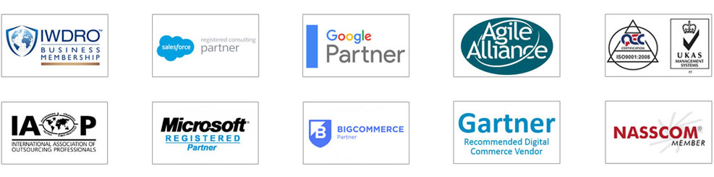

## Portfolio



Full Portfolio: https://www.dotsquares.com/client-reviews/portfolio/

## What our clients say

|  |  |  |
| --- | --- | --- |
| *“You have been one of the best developers I have ever worked with. You have excellent technical and interpersonal skills and you got my website development and design project done to my amazement and satisfaction!”* | *“Significant cost savings can be made working with an outsourced development company you can trust. Dotsquares have an exceptional team of quality engineers who work quickly and are always aware of deadlines.”* | *“Dotsquares went beyond the requirements. The Team are amazing and working with them is a winning formula. I feel extremely lucky to have these gentlemen on my Team with their unyielding dedication to excellence.”* |
| **John Wussah**  Education & Training Company  Australia | **Daniel Ox**  Ocean Holidays Group  UK | **Brian Riback**  New York Daily News  USA |

View more testimonials at: [www.dotsquares.com/client-reviews/testimonials/](http://www.dotsquares.com/client-reviews/testimonials/)